CANDIDATE INFORMATION SHEET
(Please fill the form in “BLOCK letters” and ensure NO field is left blank)

Personal Information

First Name (as in Aadhaar Card) |  | UDHAYAKUMAR |  |  | 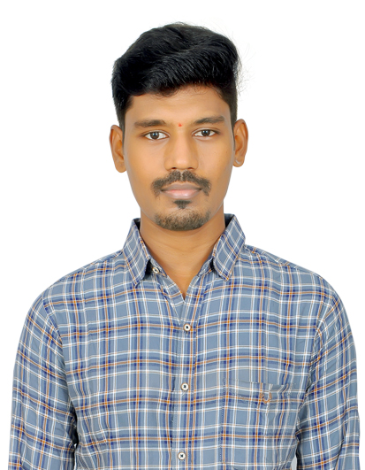
Middle Name, (as in Aadhaar Card)
Last Name (as in Aadhaar Card) |  | B S
Interview Date | 13/12/2023 | DOB | 01/07/1997
Address |  | 123, G.S.POOVIKA MAGIZHCHI ILLAM, BHARATHI ESTATE, NEAR EB OFFICE, KOMARAPALAYAM - 638183
Mobile No. | +91 8778365553 | Alternate No. | NA
Email ID 1 | udhayayuvan007@gmail.com |  |  | Email ID 2 | NA
PAN card number | AEXPU2023A |  |  | Aadhaar number (12 Digit) | 567005776959

Work Authorization Status

Nationality |  | INDIAN | Indian Citizenship |  | YES
If you are NOT an Indian Citizen, please provide details of your India work authorization in any one of the below fields from (a) to (d):
(a) | PIO - PIO Card No. |  | Issue Date |  | Valid till
(b) | OCI – OCI No. |  | Issue Date |  | Valid till
(c) | India Employment Visa – Visa reference No. |  | Issue Date |  | Valid till
(d) | Others, if any – Please give more details

Educational Qualification

Qualification |  | Degree &  Specialization | School/ College Name | University Name | Full /  Part Time | % or CGPA | From (MM/YY) | To (MM/YY) | Document Available  (Yes/No)
10th | MATHS, SCIENCE |  | GOVERNMENT BOYS HIGHER SECONDARY SCHOOL | STATE BOARD | FULL TIME | 86.6% | 06/2011 | 04/2012 | YES
12th | MATHS, COMPUTER SCIENCE |  | SRI RAGHAVENDRA MATRIC HIGHER SECONDARY SCHOOL | STATE BOARD | FULL TIME | 94.75% | 05/2013 | 03/2014 | YES
UG |  | BE  MECHANICAL ENGINEERING | SASURIE ACADEMY OF ENGINEERING | ANNA UNIVERSITY | FULL TIME | 8.11CGPA | 08/2014 | 05/2018 | YES
PG
Other Qualification

Employment History
Current Organization

S No | Organization Name | From (Date) | To (Date) | Permanent / Contract | Designation on Exit | Reason for Leaving | Supporting documents available?
1 | LTIMINDTREE | 28-07-2022 | TILL | PERMANENT | CLOUD ENGINEER | LOOKING FOR CHALLENGING OPPORTUNITY | YES

Previous Organizations
S No | Organization Name | From (Date) | To (Date) | Permanent/Contract | Designation on Exit | Reason for Leaving | Supporting documents available?
1 | TATA CONSULTANCY SERVICES | 28-01-2019 | 21-09-2021 | PERMANENT | SYSTEM ENGINEER | SALARY ISSUE | YES
2 | CAPGEMINI TECHNOLOGY SERVICES INDIA LIMITED | 22-09-2021 | 25-07-2022 | PERMANENT | ASSOCIATE CONSULTANT | NOT SATISFIED WITH THE PROJECT ROLE | YES

For HR Use Only (to be filled by Infra Services & BPS candidates only)
Please confirm if you have understood the following | Signature of the Candidate
- Compensation break discussed during the HR Discussion  - The Transport boundary details and have understood it  - Willingness to work in night shifts  - Willingness to work in 24/7 shifts (For CIS only) | 

Compensation Details
Current Compensation |  | Expected Compensation
Fixed Pay (p.a.) | 1300000 | 1700000
Variable Pay (p.a.) | NA | Remarks (If any):
Variable Payout Pattern | Quarterly / Half Yearly / Annual | Remarks (If any):
Gross CTC (p.a.) |  | Remarks (If any):

Other Information
Last Promotion (MM / YY) | 07/2022 | Last Salary Revision (MM / YY) | 07/2022
If you are an ex - Cognizant employee, please mention your Associate ID |  |  | NA
Please mention your Notice Period [or] the date by which you can join us [whichever is earlier] |  |  | 3 MONTHS

FOR YOUR ATTENTION
- Cognizant does not entertain payments of any kind from candidates or vendors for employment. Requests for such payments or any mails purporting to come from Cognizant seeking personal or financial details should be promptly reported to TAGCompliance@Cognizant.com
- If you encounter anyone who claims to offer jobs at Cognizant in return for any benefit (monetary or non-monetary) please do not entertain them. Please be informed that Cognizant shall not be held responsible for any such instances or payments you make
- To ascertain that you are receiving an official call from Cognizant please collect the caller’s details like full name; employee ID; and mobile number

